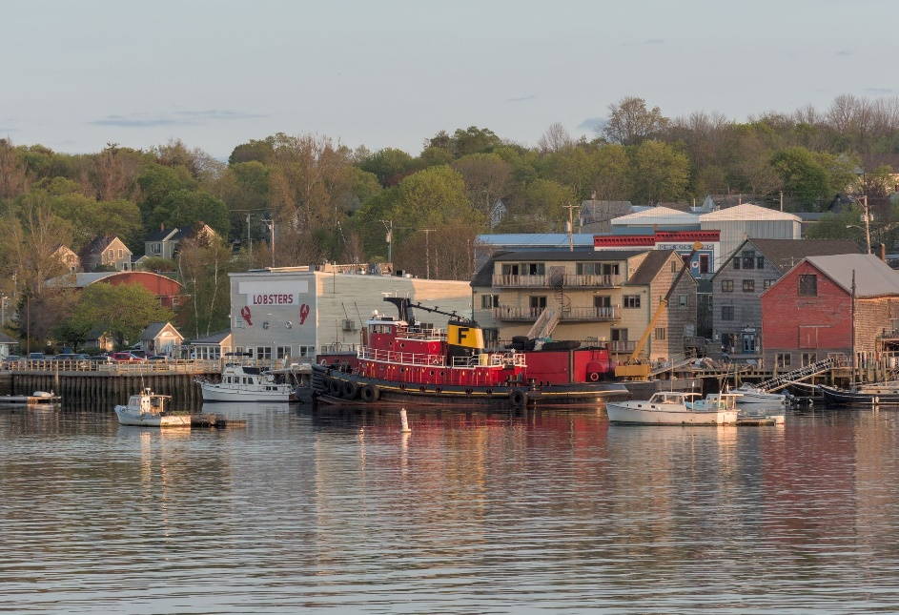
Belfast, Maine

2019 Inventory of Communitywide
Greenhouse Gas Emissions

September 2021

Produced by the City of Belfast Climate Crisis Committee
With Assistance from ICLEI - Local Governments for Sustainability USA

© 2020 ICLEI-Local Governments for Sustainability USA. All Rights Reserved.
Credits and Acknowledgements

For local information, City of Belfast, ME Erin Herbig, City Manager, City of Belfast, ME
Brent Martin, Assessor, City of Belfast, ME
Michael McFadden, Transfer Station Manager, City of Belfast, ME
Annaliese Hafford, at Olver Associates, firm superintending Wastewater Treatment Plant, Belfast, ME
Keith Pooler, Superintendent, Belfast Water District, Belfast, ME
Tamra Pierce, Key Account Manager, Kennebec Valley & Penobscot Regions, Central Maine Power Company
Chamberlin, Doug, photographs

For Belfast & Waldo County transportation data
Denise Cormier, ESS III, Bureau of Air Quality, Maine Department of Environmental Protection
For initial contacts with state agencies
Brian Ambrette, Senior Climate Resilience Coordinator, Governor’s Office of Policy Innovation and the Future (GOPIF)
For initial encouragement and suggestions based on personal experience
Janet McMahon, Science faculty and supervisor of students at the Waterfront School, Camden, ME, who produced a GHGI via ICLEI/Clearpath for their hometown

ICLEI-Local Governments for Sustainability USA

Table of Contents

Table of Contents 2
Tables and Figures 4
List of Tables 4
List of Figures 4
Executive Summary 5
Key Findings 7
Introduction to Climate Change 8
Greenhouse Gas Inventory as a Step Toward Carbon Neutrality 11
ICLEI Climate Mitigation Milestones 11
Inventory Methodology 13
Understanding a Greenhouse Gas Emissions Inventory 13
Community Emissions Protocol 14
Quantifying Greenhouse Gas Emissions 14
Sources and Activities 14
Base Year 15
Quantification Methods 15
Community Emissions Inventory Results 16
Next Steps 17
Conclusion 17
Appendix: Methodology Details 19
Energy 19
Transportation 20
Wastewater 20
Potable Water 21
Solid Waste 21
Inventory Calculations 21

Tables and Figures

List of Tables
Table 1: Global Warming Potential Values (IPCC,2018) 12
Table 2: Communitywide Emissions Inventory 15
Table 3: Energy Data Sources 18
Table 4: Emissions Factors for Electricity Consumption 18
Table 5: Transportation Data Sources 19
Table 6: MPG and Emissions Factors by Vehicle Type 19

List of Figures
Figure 1: Communitywide Emissions by Sector 6
Figure 2: ICLEI Climate Mitigation Milestones 11
Figure 3: Relationship of Communitywide and Government Operations Inventories 12
Figure 4: Communitywide Emissions by Sector 16

Executive Summary
The City of Belfast recognizes that greenhouse gas (GHG) emissions from human activity are catalyzing profound climate change, the consequences of which pose substantial risks to the future health, wellbeing, and prosperity of our community.
Belfast began its long-term commitment to sustainability in 2007. A predecessor City committee to ours began a weatherization campaign for Belfast homes that not only worked on individual homes, but produced training videos, eventually merging with the all-volunteer Window Dressers program, which has spread statewide. Also, the committee introduced efforts to reduce idling. Finally, they completed a GHGI under the auspices of ICLEI. (2008)
Starting in 2014, a City Energy Committee focused on reducing fossil fuel use in City operations so as to save the City money on its fuel budget. They have overseen several small and large solar projects on City property, now offsetting 90% of the electricity used in City buildings overall. They have done municipal building lighting and street lighting retrofits, completed numerous audits of City buildings for energy-efficiency, and installed two charging stations for electric vehicles on City property, with another four under contract. Most notably, they undertook a 3-year audit of the City’s wastewater treatment plant, followed by an upgrade achieving major energy savings. They continue to pursue projects promoting energy efficiency in City buildings.
The present Climate Crisis Committee formed in 2018 with a mission “to catalyze actions throughout the Belfast community for a sustainable future while adapting to climate change.” Progress to date has been as follows:
--Completed 3-part detailed report and recommendations for City on addressing sea-level rise.
(2018-2019)
--Joined Global Covenant of Mayors (2019); ICLEI (2020); completing current GHGI (2021).
--Initiated a series of public forums to educate and engage the Belfast community re climate change. (2019-ongoing)
--Worked with a team from federal and state agencies to mark historic high water levels
at Belfast Harbor compared with predicted levels for the 21st century, displaying them
prominently with explanatory placards for the purpose of public education. (2019-2021)
--Launched three types of projects to gather high-quality local data on weather, tide levels and storm surge in Belfast Harbor, one involving Belfast Area High School students extensively in both design and implementation, another involving citizen science. (2019- 2021)
--Advised the City Council on support for state legislation that would benefit Belfast in adapting to and/or mitigating climate change. (ongoing)
--Made proposals to the City Council on a variety of long-term programs to mitigate climate change. (ongoing)
--Worked with a sister committee in Belfast—the Comprehensive Planning Committee—on introducing consideration of climate change into the City’s long-term planning cycle.
--Collaborated widely with other climate-action groups on a wide variety of short-term projects
with the long-term aim of building resources and capacity in the mid-coast region. (ongoing)
--In preparation for a Climate Action Plan to follow this GHGI, have commented on, followed closely, and sometimes participated in developments around the state’s Climate Action Plan, so as to make sure Belfast is a responsive municipal partner with the state, in synch with its policy and funding priorities. (ongoing)
This report provides estimates of greenhouse gas emissions resulting from activities in City of Belfast as a whole in 2019.

Key Findings

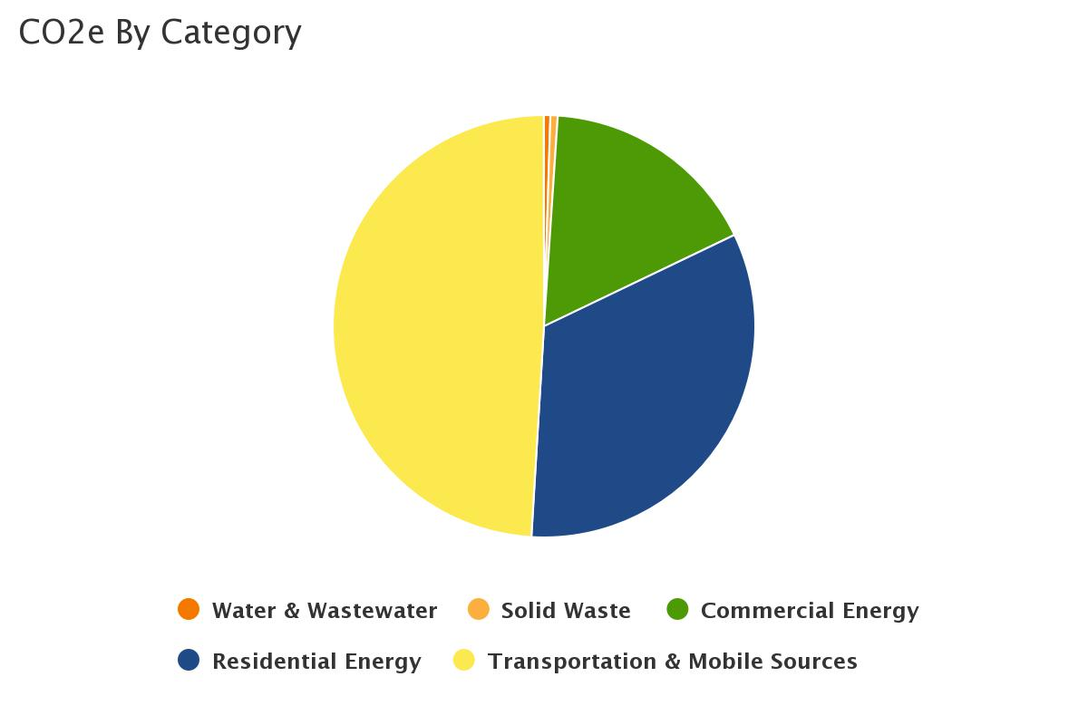
Figure 1 shows communitywide emissions by sector. The largest contributor is Transportation with 49% of emissions. The next largest contributors are Residential (33%) and Commercial (17%). Actions to reduce emissions in all of these sectors will be a key part of a climate action plan. Solid Waste, Water and Wastewater Treatment were responsible for the remaining 1% of emissions.
The Inventory Results section of this report provides a detailed profile of emissions sources within the City of Belfast; information that is key to guiding local reduction efforts. These data will also provide a baseline against which the city will be able to compare future performance and demonstrate progress in reducing emissions.
Figure 1: Communitywide Emissions by Sector

Introduction to Climate Change

Naturally occurring gases dispersed in the atmosphere determine the Earth’s climate by trapping solar radiation. This phenomenon is known as the greenhouse effect. Overwhelming evidence shows that human activities are increasing the concentration of greenhouse gases and changing the global climate. The most significant contributor is the burning of fossil fuels for transportation, electricity generation and other purposes, which introduces large amounts of carbon dioxide and other greenhouse gases into the atmosphere. Collectively, these gases intensify the natural greenhouse effect, causing global average surface and lower atmospheric temperatures to rise. Global climate change influences seasonal patterns and intensifies weather events, threatening the safety, quality of life, and economic prosperity of communities everywhere. Many regions are already experiencing the consequences of global climate change, and the City of Belfast is no exception.
Human activities are estimated to have caused approximately 1.0°C of global warming above pre-industrial levels, with a likely range of 0.8°C to 1.2°C. Global warming is likely to reach 1.5°C between 2030 and 2052 if it continues to increase at the current rate. (high confidence) Warming from anthropogenic emissions from the pre-industrial period to the present will persist for centuries to millennia and will continue to cause further long-term changes in the climate system, such as sea level rise, with associated impacts (high confidence), but these emissions alone are unlikely to cause global warming of 1.5°C (medium confidence). Climate-related risks for natural and human systems are higher for global warming of 1.5°C than at present, but lower than at 2°C (high confidence). These risks depend on the magnitude and rate of warming, geographic location, levels of development and vulnerability, and on the choices and implementation of adaptation and mitigation options (high confidence).
,
Belfast is a small city on the coast of Penobscot Bay in midcoast Maine, northern New England. We have taken the following information from the Northeast section of the National Climate Assessment closest to our baseline year of 2019 (NCA4)³, which details severe impacts to the Northeast from climate change. In the following summary, we will focus on those impacts most relevant to Maine, especially to Belfast’s coastal location.

Precipitation. The recent dominant trend in precipitation throughout the Northeast has been towards increases in rainfall intensity, with increases in intensity exceeding those in other regions of the contiguous United States.

In terms of amount, precipitation per month in the Northeast is projected to be about 1 inch greater for December through April by end of century (2070–2100) under the higher projection of global warming.

Temperature. By 2035, and under both lower and higher scenarios, the Northeast is projected to be more than 3.6°F (2°C) warmer on average than during the preindustrial era. This would be the largest increase in the contiguous United States and would occur as much as two decades before global average temperatures reach a similar milestone.

Seasonal differences are decreasing in the Northeast, as winters have warmed three times faster than summers. By the middle of this century, winters are projected to be milder still, with fewer cold extremes, particularly across Maine.

___________________________
³ National Climate Assessment #4 – Ch 18: Northeast. Retrieved from https://nca2018.globalchange.gov/chapter/18/ Most of the text is direct quotation from NCA4. Some local information has been added; some formatting and other revisions have been made in the interests of brevity and clarity.

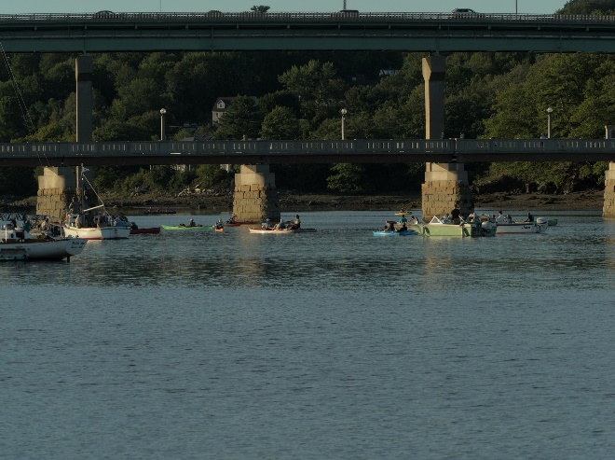

Coastal Ecosystems. The Northeast’s coast and ocean support commerce, tourism, and recreation that are important to the region’s economy and way of life. Warmer ocean temperatures, sea level rise, and ocean acidification threaten these services. The Northeast has experienced some of the highest rates of sea level rise and ocean warming in the United States, and these exceptional increases relative to other regions are projected to continue through the end of the century. Indeed, the Gulf of Maine is growing warmer at a rate faster than 99% of all the waterbodies in the world. Some of Maine’s most valuable and iconic fisheries will decline, including Atlantic cod, Atlantic sea scallops, and American lobster. In addition, species that are already endangered and federally protected—such as Atlantic sturgeon, Atlantic salmon, and right whales—are expected to be further threatened.

Sea level rise caused by global warming will impact coastal infrastructure. The greater intensity and frequency of storms adds to sea level rise in this threat. Much of the infrastructure in the Northeast is nearing the end of its planned life. Climate-related disruptions will hasten that end. Although much of Belfast’s transportation infrastructure, such as coastal Route 1, Route 3 to Augusta, and key local or county roads, as well as the airport, are on top of high banks more than 100’ above the water—likewise the power supply—the wastewater treatment plant down at the harbor may be in jeopardy under high projections for warming, while drainage systems are already overstressed. More importantly, a large number of attractions for Belfast’s tourist economy, such as the Harbor Walk, flanked by eating places and small gift/art shops, docks for commercial and recreational vessels, and public park land will be vulnerable to “normal” high-tide flooding within decades. We note that regional efforts have recommended changes in design standards when building, replacing, or retrofitting infrastructure to account for a changing climate.

Public Health. Changing climate harms the well-being of people in the Northeast through more extreme weather, warmer temperatures, and degradation of air and water quality. Increases in annual average temperatures have been 3 degrees F or more in New England since 1901. Although the relative risk of death on very hot days is lower today than it was a few decades ago due to the increased prevalence of airconditioned spaces, heat-related illness and death remain significant public health problems in the Northeast. We can expect approximately 650 additional premature deaths per year in the Northeast from extreme heat by 2050, under either a low or high projection of warming, and from 960 to 2,300 more by 2090.

Excess deaths due to ground-level ozone pollution are expected to increase substantially under both lower and higher projects of warming; and we will experience longer and more intense pollen seasons. Mold growth from dampness due to greater precipitation and/or sea-level rise will increase respiratory illnesses, including asthma symptoms and wheezing.

Vector-borne diseases from ticks and mosquitoes are already on the rise, as are waterborne diseases, such as algal blooms and vibrio spread by the run-off from more intense storms.
Adaptation. Communities in the Northeast are planning and implementing actions to reduce risks posed by climate change. Some of what Belfast has done is mentioned in the Executive
Summary of this report. As is true in many cases, including Belfast, adaptation has been limited to coping responses that address short-term needs and are feasible within the current institutional context, whereas longer-term, more transformative efforts will likely require complex policy transition planning and frameworks that can address social and economic equality. We hope that this report, along with the Climate Action Plan to follow later, will help our community enlarge its thinking about how to address the current climate crisis.
Many communities in the United States have started to take responsibility for addressing climate change at the local level. Reducing fossil fuel use in the community can have many benefits in addition to reducing greenhouse gas emissions. More efficient use of energy decreases utility and transportation costs for residents and businesses. Retrofitting homes and businesses to be more efficient creates local jobs. In addition, when residents save on energy costs, they are more likely to be spent at local businesses and add to the local economy. Reducing fossil fuel use improves air quality and increasing opportunities for walking and bicycling improves residents’ health.

Greenhouse Gas Inventory as a Step Toward Carbon Neutrality
Facing the climate crisis requires the concerted efforts of local governments and their partners, those that are close to the communities directly dealing with the impacts of climate change.
Cities, towns and counties are well placed to create and adopt coherent and inclusive plans that address integrated climate action — climate change adaptation, resilience and mitigation. Existing targets and plans need to be reviewed to bring in the necessary level of ambition and outline how to achieve net-zero emissions by 2050 at the latest. Creating a roadmap for climate neutrality requires the City of Belfast to identify priority sectors for action, while considering climate justice, inclusiveness, local job creation and many other impacts that can also deliver on sustainable development.
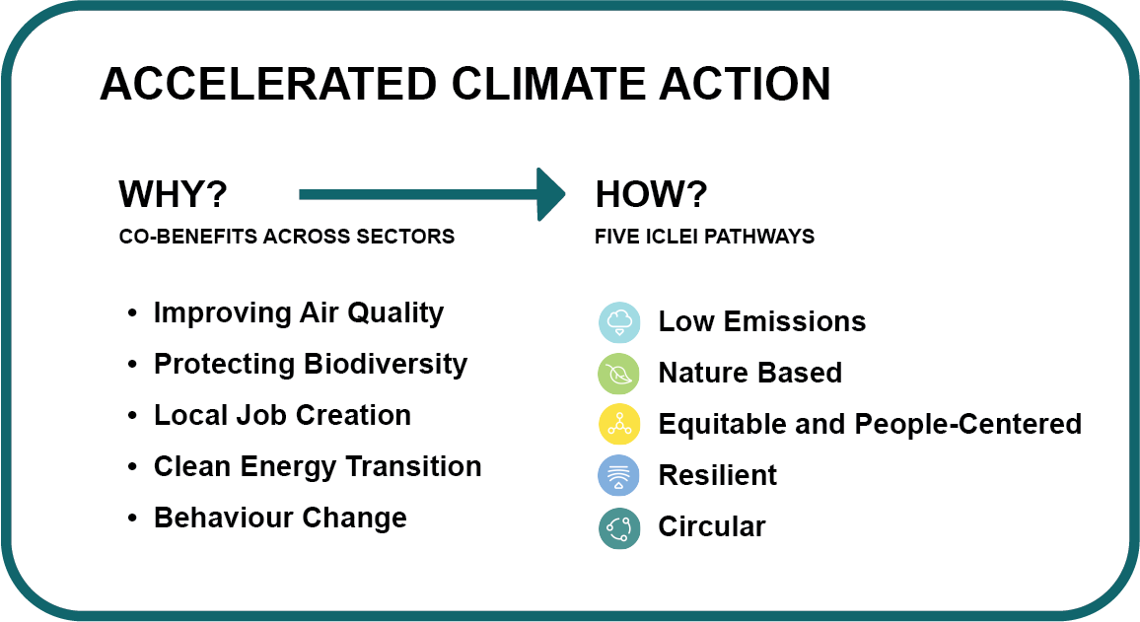
To complete this inventory, we utilized tools and guidelines from ICLEI - Local Governments for Sustainability (ICLEI), which provides authoritative direction for greenhouse gas emissions accounting and defines climate neutrality as follows:
The targeted reduction of greenhouse gas (GHG) emissions and GHG avoidance across the community in all sectors to an absolute net-zero emission level at the latest by 2050. In parallel to this, it is critical to adapt to climate change and enhance climate resilience across all sectors, in all systems and processes.
To achieve ambitious emissions reduction, and move toward climate neutrality, the City of Belfast will need to set a clear goal and act rapidly following a holistic and integrated approach. Climate action is an opportunity for our community to experience a wide range of co-benefits, such as creating socio-economic opportunities, reducing poverty and inequality, and improving the health of people and nature.

ICLEI Climate Mitigation Milestones
In response to the climate emergency, many communities in the United States are taking responsibility for addressing emissions at the local level. Since many of the major sources of greenhouse gas emissions are directly or indirectly controlled through local policies, local governments have a strong role to play in reducing greenhouse gas emissions within their boundaries, as well as influencing regional emissions through partnerships and advocacy. Through proactive measures around land use patterns, transportation demand management, energy efficiency, green building, waste diversion, and more, local governments can dramatically reduce emissions in their communities. In addition, local governments are primarily responsible for the provision of emergency services and the mitigation of natural disaster impacts.
Figure ICLEI Climate Mitigation Milestones
ICLEI provides a framework and methodology for local governments to identify and reduce greenhouse gas emissions, organized along Five Milestones, also shown in Figure 2:
- Conduct an inventory and baseline of local greenhouse gas emissions;
- Establish a greenhouse gas emissions Science Based Target;
- Develop a climate action plan for achieving the emissions reduction target;
- Implement the climate action plan;
- Monitor and report on progress.
This report represents the completion of ICLEI’s Climate Mitigation Milestone One, and provides a foundation for future work to reduce greenhouse gas emissions in the City of Belfast.
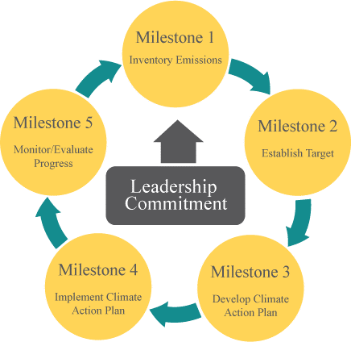

Figure 2: ICLEI Climate Mitigation Milestones

Inventory Methodology

Understanding a Greenhouse Gas Emissions Inventory
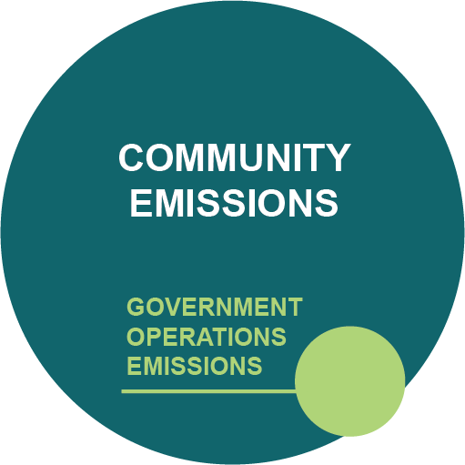
The first step toward achieving tangible greenhouse gas emission reductions requires identifying baseline emissions levels and the sources and activities generating emissions in the community. This report presents emissions from the City of Belfast as a whole. A government operations inventory is mostly a subset of the community inventory, as shown in Figure 3. For example data on commercial energy use by the community includes energy consumed by municipal buildings, and community vehicle-miles-traveled estimates include miles driven by municipal fleet vehicles.
Figure 3: Relationship of Communitywide and Government Operations Inventories

As local governments have continued to join the climate protection movement, the need for a standardized approach to quantify GHG emissions has proven essential. This inventory uses the approach and methods provided by the U.S. Community Protocol for Accounting and Reporting Greenhouse Gas Emissions (Community Protocol), which is described below.
Three greenhouse gases are included in this inventory: carbon dioxide (CO₂), methane (CH₄) and nitrous oxide (N₂O). Many of the charts in this report represent emissions in “carbon dioxide equivalent” (CO₂e) values, calculated using the Global Warming Potentials (GWP) for methane and nitrous oxide from the IPCC 5th Assessment Report:

Table 1: Global Warming Potential Values (IPCC, 2014)
Greenhouse Gas | Global Warming  Potential
Carbon Dioxide (CO₂) | 1
Methane (CH₄) | 28
Nitrous Oxide (N₂O) | 265

Community Emissions Protocol
Version 1.2 of the U.S. Community Protocol for Accounting and Reporting GHG Emissions was released by ICLEI in 2019, and represents a national standard in guidance to help U.S. local governments develop effective community GHG emissions inventories. It establishes reporting requirements for all community GHG emissions inventories, provides detailed accounting guidance for quantifying GHG emissions associated with a range of emission sources and community activities, and provides a number of optional reporting frameworks to help local governments customize their community GHG emissions inventory reports based on their local goals and capacities.

The community inventory in this report includes emissions from the five Basic Emissions Generating Activities required by the Community Protocol. These activities are:

- Use of electricity by the community
- Use of fuel in residential and commercial stationary combustion equipment
- On-road passenger and freight motor vehicle travel
- Use of energy in potable water and wastewater treatment and distribution
- Creation of solid waste by the community

The community inventory also includes the following activities:
- Wastewater processing

Quantifying Greenhouse Gas Emissions

Sources and Activities
Communities contribute to greenhouse gas emissions in many ways. Two central categorizations of emissions are used in the community inventory: 1) GHG emissions that are produced by “sources” located within the community boundary, and 2) GHG emissions produced as a consequence of community “activities”.
Source
Any physical process inside the jurisdictional boundary that releases GHG emissions into the atmosphere
Activity
The use of energy, materials, and/or services by members of the community that result in the creation of GHG emissions.

By reporting on both GHG emissions sources and activities, local governments can develop and promote a deeper understanding of GHG emissions associated with their communities. A purely source‐based emissions inventory could be summed to estimate total emissions released within the community’s jurisdictional boundary. In contrast, a purely activity‐based emissions inventory could provide perspective on the efficiency of the community, even when the associated emissions occur outside the jurisdictional boundary. The division of emissions into sources and activities replaces the scopes framework that is used in government operations inventories, but that does not have a clear definition for application to community inventories.

Base Year
The inventory process requires the selection of a base year with which to compare current emissions. The City of Belfast’s community greenhouse gas emissions inventory utilizes 2019 as its baseline year, because it is the most recent year for which the necessary data are available.

Quantification Methods
Greenhouse gas emissions can be quantified in two ways:
- Measurement-based methodologies refer to the direct measurement of greenhouse gas emissions (from a monitoring system) emitted from a flue of a power plant, wastewater treatment plant, landfill, or industrial facility.
- Calculation-based methodologies calculate emissions using activity data and emission factors. To calculate emissions accordingly, the basic equation below is used:
Activity Data x Emission Factor = Emissions
Most emissions included in this inventory are quantified using calculation-based methodologies. Activity data refer to the relevant measurement of energy use or other greenhouse gas-generating processes such as fuel consumption by fuel type, metered annual electricity consumption, and annual vehicle miles traveled. Please see appendices for a detailed listing of the activity data used in composing this inventory.
Known emission factors are used to convert energy usage or other activity data into associated quantities of emissions. Emissions factors are usually expressed in terms of emissions per unit of activity data (e.g. lbs CO₂/kWh of electricity). For this inventory, calculations were made using ICLEI’s ClearPath tool.

Community Emissions Inventory Results
The total communitywide emissions for the 2019 inventory are shown in Table 2 and Figure 4.

Table 2: Communitywide Emissions Inventory

Sector | Fuel or source | 2019 Usage | Usage unit | 2019 Emissions (MTCO₂e)
Residential energy | Electricity (Central Maine Power) | 23,268,193 | kWh | 5,160
Residential energy | Natural Gas (Propane) | 43,659 | MMBtu | 2,683
Residential energy | Heating Oil (#2 Fuel) | 163,300 | MMBtu | 12,078
Residential energy | Wood | 119,000 | MMBtu | 1,185
Residential energy total |  |  |  | 21,106
Commercial energy | Electricity | 48,034,823 | kWh | 10,652
Commercial energy | Propane | 1,060 | MMBtu | 61
Commercial energy total |  |  |  | 10,652
On-road transportation | Gasoline (passenger vehicles) | 55,955,825 | Vehicle Miles | 21,676
On-road transportation | Diesel (freight trucks and passenger) | 4,043,024 | Vehicle Miles | 7,829
Transit | Diesel | 1,477,529 | Vehicle Miles | 2,018
Transportation total |  |  |  | 31,523
Solid Waste | Waste Generated | 700 | Tons | 366
Solid Waste | Landfill Gas (50% Methane) | 9,832 | CF/Day | 0.47
Solid waste total |  |  |  | 366
Water and wastewater | Water Treatment Energy Usage | 247,479 | kWh | 55
Water and wastewater | Wastewater Treatment Energy Usage | 900,000 | kWh | 202
Water and wastewater | Nitrogen Discharge | 70 | Kg/day | 53
Water and wastewater total |  |  |  | 308
Total community-wide emissions |  |  |  | 64,285

Figure 4 shows the distribution of communitywide emissions by sector. Transportation is the largest contributor, followed by Residential and Commercial.
Figure 4: Communitywide Emissions by Sector,
(see page for percentages)

Next Steps
The results of this GhGI will be incorporated into the Climate Action Plan that we plan to develop with city leaders and the Belfast community.

The inventory results should be used to focus and prioritize actions to reduce emissions. Based on the inventory results, the following areas and possible approaches have the greatest potential for emissions reduction:
- Transportation and Mobile Sources – increase number of EV charging stations, increase miles of multimodal paths and lanes, increase frequency of DASH bus runs.
- Residential Energy – increase heat pump installations, increase use of Window Dresser inserts and other energy efficiency improvements
- Commercial Energy – coordinate with Chamber of Commerce to provide energy efficiency information, increase heat pump installations, awards program for increased energy efficiency.
Completion of another GHG inventory in two to five years is recommended in order to assess progress resulting from any actions implemented. The detailed methodology section of this report, as well as notes and attached data files in the ClearPath tool and a file of documents maintained by the City of Belfast Climate Crisis Committee, will be helpful to complete a future inventory consistent with this one.

Conclusion

This inventory marks the completion of Milestone One of the Five ICLEI Climate Mitigation Milestones. The next steps are to set an emissions-reduction target; develop a climate action plan that identifies specific quantified strategies and specific schedules to meet that target; implement the plan; and monitor it for progress in reductions.
The Intergovernmental Panel on Climate Change (IPCC) states that to meet the Paris Agreement commitment of keeping warming below 1.5°C we must reduce global emissions by 50% by 2030 and reach climate neutrality by 2050. Equitably reducing global emissions by 50% requires that high-emitting, wealthy nations reduce their emissions by more than 50%. More than ever, it is imperative that countries, regions, and local governments set targets that are ambitious enough to slash carbon emissions between now and mid-century.
Science-Based Targets are calculated climate goals, in line with the latest climate science, that represent a community’s fair share of the global ambition necessary to meet the Paris Agreement commitment. To achieve a science-based target, community education, involvement, and partnerships will be instrumental.
ICLEI has provided Belfast with a method to project future emissions through 2030, taking into account population growth and projected aggressive utility decarbonization. ICLEI has also provided a template that Belfast could use to reduce GHG emissions. This analysis will help shape the next phase of Belfast’s Climate Action Plan with potential strategies that contribute to emissions reductions in the key energy sectors.
In addition, the City of Belfast will continue to update the GhGI on a biannual basis. It is recommended that communities update their inventories on a regular basis, especially as plans are implemented to ensure measurement and verification of impacts. Regular inventories also allow for “rolling averages” to provide insight into sustained changes and can help reduce the chance of an anomalous year being incorrectly interpreted. This inventory shows that reducing VMTs and increasing commercial and/or residential building efficiencies will be particularly important to focus on. Through these efforts and others, the City of Belfast can achieve environmental, economic, and social benefits beyond reducing emissions.

Appendix: Methodology Details

Energy
The following table shows each activity related to energy consumption, data source, and notes on data gaps.
Table 3: Energy Data Sources
Activity | Data Source | Data Gaps/Assumptions
Communitywide
Residential, commercial, and industrial electricity consumption | CMP | Industrial included in Commercial
Residential, commercial, and industrial natural gas consumption | NREL
Residential Propane Consumption | USEIA, City*
Residential Heating Oil Consumption | USEIA, City*
Residential Wood Consumption | USEIA, City*
Commercial Propane Consumption | NREL https://gds.nrel.gov/slope.

Table 4: Emissions Factors for Electricity Consumption
Year | CO₂ (lbs./MWh) | CH₄ (lbs./GWh) | N₂O (lbs./GWh)
2019 | 488.9 | 77 | 10

Transportation
Table 5: Transportation Data Sources
Activity | Data Source | Data Gaps/Assumptions
Communitywide
Inventory of Vehicles and Fuel | Maine DEP | Calculated from County VMT based on Belfast registrations
Transit ridership | n/a

For vehicle transportation, it is necessary to apply average miles per gallon and emissions factors for CH₄ and N₂O to each vehicle type. The factors used are shown in Table 6.

Table 6: MPG and Emissions Factors by Vehicle Type
Fuel | Vehicle type | MPG | CH₄ g/mile | N₂O g/mile
Gasoline | Passenger car | 24.2 | .375 | .0031
Gasoline | Light truck | 17.5 | .375 | .0043
Gasoline | Heavy truck | 6.5 | .375 | .0115
Gasoline | Motorcycle | 44.0 | .375 | .0017
Diesel | Passenger car | 24.2 | .0171 | .0828
Diesel | Light truck | 7.5 | .0552 | .0110
Diesel | Heavy truck | 5.29 | .0783 | .0157

Emissions calculations based on information from Bureau of Transportation Statistics: www.fueleconomy.gov and Alternative Fuels Data Center

Wastewater
Table 7: Waste Water Treatment Plant
Activity | Data Source | Data Gaps/Assumptions
Communitywide Operations
Nitrogen Discharge | Olver Associates, City*
Energy used in wastewater facilities | Olver Associates, City*

Potable Water
Table 8: Belfast Water District

Activity | Data Source | Data Gaps/Assumptions
Communitywide
Water  usage | Belfast Water District* | None

Solid Waste
Table 9: Belfast Transfer Station

Activity | Data Source | Data Gaps/Assumptions
Communitywide
Waste Streams | City Staff*
Annual MSW Tonnage | Municipal Review Committee
Recycling | City Staff* | Estimated based on 2020 data, calculation to fit 2019

*See acknowledgements section.

Inventory Calculations
The 2019 inventory was calculated following the US Community Protocol and ICLEI’s ClearPath software. As discussed in Inventory Methodology, the IPCC 5th Assessment was used for global warming potential (GWP) values to convert methane and nitrous oxide to CO₂ equivalent units. ClearPath’s inventory calculators allow for input of the sector activity (i.e. kWh or VMT) and emission factor to calculate the final CO₂e emissions.

This document is licensed by ICLEI under an International Creative Commons license CC BY-NC-ND 4.0. Users may share this product without prior authorization provided that (1) attribution of authorship is provided to ICLEI - Local Governments for Sustainability USA, (2) that the user does not significantly alter the content of the product, and (3) that the user does not use it for commercial purposes.

International Panel on Climate Change. 2014. Climate Change 2014: Synthesis Report. Contribution of Working Groups I, II and III to the Fifth Assessment Report of the Intergovernmental Panel on Climate Change [Core Writing Team, R.K. Pachauri and L.A. Meyer (eds.)]. IPCC, Geneva, Switzerland, 151 pp. Retrieved from https://www.ipcc.ch/report/ar5/syr/
IPCC, 2018: Summary for Policymakers. In: Global Warming of 1.5°C. An IPCC Special Report on the impacts of global warming of 1.5°C above pre-industrial levels and related global greenhouse gas emission pathways, in the context of strengthening the global response to the threat of climate change, sustainable development, and efforts to eradicate poverty [Masson-Delmotte, V., P. Zhai, H.-O. Pörtner, D. Roberts, J. Skea, P.R. Shukla, A. Pirani, W. Moufouma-Okia, C. Péan, R. Pidcock, S. Connors, J.B.R. Matthews, Y. Chen, X. Zhou, M.I. Gomis, E. Lonnoy, T. Maycock, M. Tignor, and T. Waterfield (eds.)]. World Meteorological Organization, Geneva, Switzerland, 32 pp.
Science-Based Targets are calculated climate goals, in line with the latest climate science, that represent your community’s fair share of the ambition necessary to meet the Paris Agreement commitment of keeping warming below 1.5°C. To achieve this goal, the Intergovernmental Panel on Climate Change (IPCC) states that we must reduce global emissions by 50% by 2030 and achieve climate neutrality by 2050. Equitably reducing global emissions by 50% requires that high-emitting, wealthy nations reduce their emissions by more than 50%.
ICLEI. 2012. US Community Protocol for Accounting and Reporting Greenhouse Gas Emissions. Retrieved from http://www.icleiusa.org/tools/ghg-protocol/community-protocol

